Conclusion
Experiment Setup & Design Options

Discussion & Key Findings
‘Treap’ Explanation
A ‘Treap’ is a mixture of both Tree and Heap Data Structures. The Treap’s nodes are sorted like a tree based off the keys value and sorted like a heap based off of the priority value. Keys are the values of the elements being inserted into the Treap and the priority is a randomly generated value assigned to each element upon insertion. In a Treap, no parent has a smaller priority value than their child, no left child has a greater key value than their parent and no right child has a smaller key value than their parent.
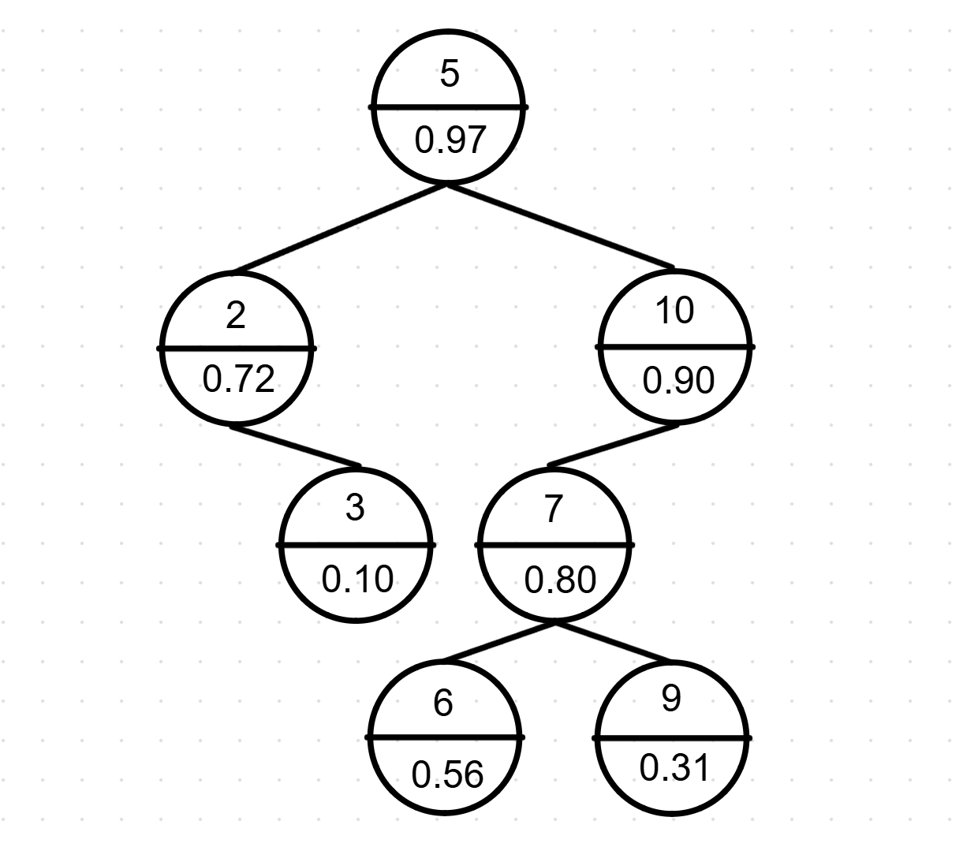

Sorting Results
Aim and Background
The aims for this assignment were as follows:
- To understands and implement randomised balanced binary search trees.
- To analyse the algorithmic time complexity of data structure operations.
- To conduct empirical performance testing and benchmarking.
- To compare different implementations on common sorting algorithms.

We implemented a Treap in java and compared it’s performance against AVLTreeMap and Java’s TreeMap as well as benchmarking Treap-Based Sorting against other sorting algorithms.


COMP20280 – Data Structures
Randomised Search Trees: The ‘Treap’,
Group 35 – Aleksandr Ivanov, Martin McSweeney, Samuel Boyle, Sanidhya Arora

